section : B

name : Muhammad usama.

Roll No : 17f_8195.

Assignment # 3.

Task 1:

#include<iostream>

#include<string>

using namespace std;

struct drinkmachine

{

string name;

int cost;

int NOfDrinks;

};// machine;

int main()

{

char chose;

string ok;

int amount=0;

bool flage=true;

char more={0};

drinkmachine *ptr;

ptr=new drinkmachine[4];

(ptr+0)->cost=75;

(ptr+0)->name="cola";

(ptr+0)->NOfDrinks=20;

(ptr+1)->cost=75;

(ptr+1)->name="root beer";

(ptr+1)->NOfDrinks=20;

(ptr+2)->cost=80;

(ptr+2)->name="grape soda";

(ptr+2)->NOfDrinks=20;

(ptr+3)->cost=80;

(ptr+3)->name="cream soda";

(ptr+3)->NOfDrinks=20;

while(flage==true)

{

cout<<" press c for : "<<(ptr+0)->name<<endl;

cout<<" press r for : "<<(ptr+1)->name<<endl;

cout<<" press g for : "<<(ptr+2)->name<<endl;

cout<<" press m for : "<<(ptr+3)->name<<endl;

cout<<" press e for exit"<<endl;

cin>>chose;

cout<<"total amount in the machine : "<<amount<<endl;

if(chose=='c'||chose=='C')

{

cout<<"no of cola drinks left :"<<(ptr+0)->NOfDrinks<<endl;

cout<<"amount of drink :"<<(ptr+0)->cost<<endl;

if((ptr+0)->NOfDrinks!=0)

{

cout<<"press ok for buy drink"<<endl;

cin>>ok;

if(ok=="ok")

{

(ptr+0)->NOfDrinks=(ptr+0)->NOfDrinks-1;

amount=amount+75;

cout<<"now total amount in machine is : "<<amount<<endl;

cout<<"no of cola drinks left :"<<(ptr+0)->NOfDrinks<<endl;

cout<<"if you want to buy more drinks press m "<<endl;

cin>>more;

if(more=='m')

{

chose='0';

system("cls");

flage=true;

}

else

{

flage=false;

}

}

}

else

{

cout<<"there is no drink avaliable"<<endl;

}

}

if(chose=='r'||chose=='R')

{

cout<<"no of root bear left :"<<(ptr+1)->NOfDrinks<<endl;

cout<<"amount of drink :"<<(ptr+1)->cost<<endl;

if((ptr+1)->NOfDrinks!=0)

{

cout<<"press ok for buy drink"<<endl;

cin>>ok;

if(ok=="ok")

{

(ptr+1)->NOfDrinks=(ptr+1)->NOfDrinks-1;

amount=amount+75;

cout<<"now total amount in machine is : "<<amount<<endl;

cout<<"no of root bear left :"<<(ptr+1)->NOfDrinks<<endl;

cout<<"if you want to buy more drinks press m "<<endl;

cin>>more;

if(more=='m')

{

chose='0';

system("cls");

flage=true;

}

else

{

flage=false;

}

}

}

else

{

cout<<"there is no drink avaliable"<<endl;

}

}

if(chose=='g'||chose=='G')

{

cout<<"no of grape soda left :"<<(ptr+2)->NOfDrinks<<endl;

cout<<"amount of drink :"<<(ptr+2)->cost<<endl;

if((ptr+1)->NOfDrinks!=0)

{

cout<<"press ok for buy drink"<<endl;

cin>>ok;

if(ok=="ok")

{

(ptr+2)->NOfDrinks=(ptr+2)->NOfDrinks-1;

amount=amount+80;

cout<<"now total amount in machine is : "<<amount<<endl;

cout<<"no of root bear left :"<<(ptr+2)->NOfDrinks<<endl;

cout<<"if you want to buy more drinks press m "<<endl;

cin>>more;

if(more=='m')

{

chose='0';

system("cls");

flage=true;

}

else

{

flage=false;

}

}

}

else

{

cout<<"there is no drink avaliable"<<endl;

}

}

if(chose=='m'||chose=='M')

{

cout<<"no of root bear left :"<<(ptr+3)->NOfDrinks<<endl;

cout<<"amount of drink :"<<(ptr+3)->cost<<endl;

if((ptr+3)->NOfDrinks!=0)

{

cout<<"press ok for buy drink"<<endl;

cin>>ok;

if(ok=="ok")

{

(ptr+3)->NOfDrinks=(ptr+3)->NOfDrinks-1;

amount=amount+80;

cout<<"now total amount in machine is : "<<amount<<endl;

cout<<"no of cream soda left :"<<(ptr+3)->NOfDrinks<<endl;

cout<<"if you want to buy more drinks press m "<<endl;

cin>>more;

if(more=='m')

{

chose='0';

system("cls");

flage=true;

}

else

{

flage=false;

}

}

}

else

{

cout<<"there is no drink avaliable"<<endl;

}

}

if(chose=='e'||chose=='E')

{

system("pause");

return 0;

}

}//while loop of flage ;

delete []ptr;

ptr=NULL;

system("pause");

return 0;

}

Result:

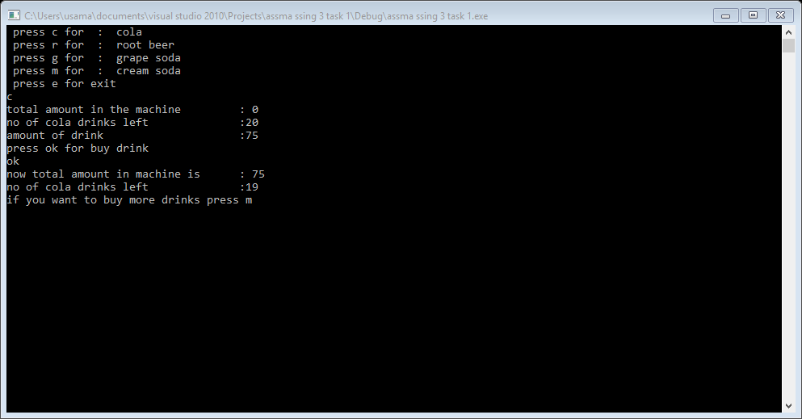

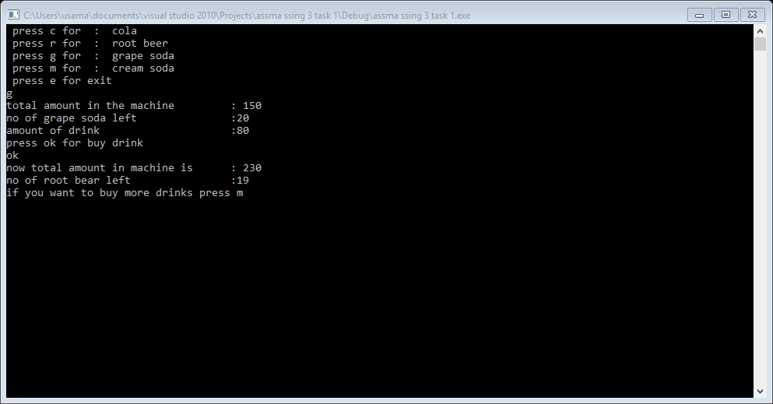

Task 2:

#include<iostream>

#include<string>

using namespace std;

struct student

{

string Fname;

string Lname;

int score;

char grade;

int cgpa;

};

void input(student *ptr, int size);

void grades(student *ptr, int size);

void highestScore(student *ptr, int size,int &adres);

//void highestcgpa(student *ptr, int size,int &adres);//redundancy because this work also done by highestscore function

void print_name(student *ptr, int size,int &adres);

int main()

{

int adres=0;

int size=0;

cout<<"how many student : ";

cin>>size;

student *ptr;

ptr=new student[size];

input(ptr,size);

grades(ptr,size);

highestScore(ptr,size,adres);

//highestcgpa(ptr,size,adres);

print_name(ptr,size,adres);

delete []ptr;

ptr=NULL;

system("pause");

return 0;

}

void input(student *ptr, int size)

{

for(int i=0; i<size; i++)

{

cout<<"enter the First name of student "<<i+1<<" : ";

cin>>ptr[i].Fname;

cout<<"enter the Last name of student "<<i+1<<" : ";

cin>>ptr[i].Lname;

}

for(int i=0; i<size; i++)

{

cout<<"enter the test score of "<<ptr[i].Fname<<" "<<ptr[i].Lname<<" : ";

cin>>ptr[i].score;

}

}

void grades(student *ptr, int size)

{

for(int i=0; i<size; i++)

{

if(ptr[i].score>=90)

{

ptr[i].grade='A+';

ptr[i].cgpa=4;

}

else if(ptr[i].score=85)

{

ptr[i].grade='A';

ptr[i].cgpa=3.67;

}

else if(ptr[i].score>=80)

{

ptr[i].grade='B+';

ptr[i].cgpa=3.4;

}

else if(ptr[i].score>=75)

{

ptr[i].grade='B';

ptr[i].cgpa=3;

}

else if(ptr[i].score>=70)

{

ptr[i].grade='C+';

ptr[i].cgpa=2.6;

}

else if(ptr[i].score>=65)

{

ptr[i].grade='C';

ptr[i].cgpa=2.2;

}

else if(ptr[i].score>=50)

{

ptr[i].grade='D+';

ptr[i].cgpa=1.7;

}

else if(ptr[i].score>=40)

{

ptr[i].grade='D';

ptr[i].cgpa=1.3;

}

else if(ptr[i].score<40)

{

ptr[i].grade='F';

ptr[i].cgpa=0;

}

else

{

cout<<"invalid case"<<endl;

}

}

}

void highestScore(student *ptr, int size,int &adres)

{

int highest=0;

adres=0;

for(int i=0; i<size; i++)

{

if(highest<ptr[i].score)

{

highest=(ptr+i)->score;

adres=i;

}

}

}

/*void highestcgpa(student *ptr, int size,int &adres)

{

int highest=0;

cgpaadres=0;

for(int i=0; i<size; i++)

{

if(highest<ptr[i].cgpa)

{

highest=(ptr+i)->cgpa;

adres=i;

}

}

}*/

void print_name(student *ptr, int size,int &adres)

{

cout<<"highest score "<<ptr[adres].score<<" got by "<<ptr[adres].Fname<<" "<<ptr[adres].Lname<<" and cgpa of "<<ptr[adres].Fname<<" "<<ptr[adres].Lname<<" "<<ptr[adres].cgpa<<endl;

}

Result:

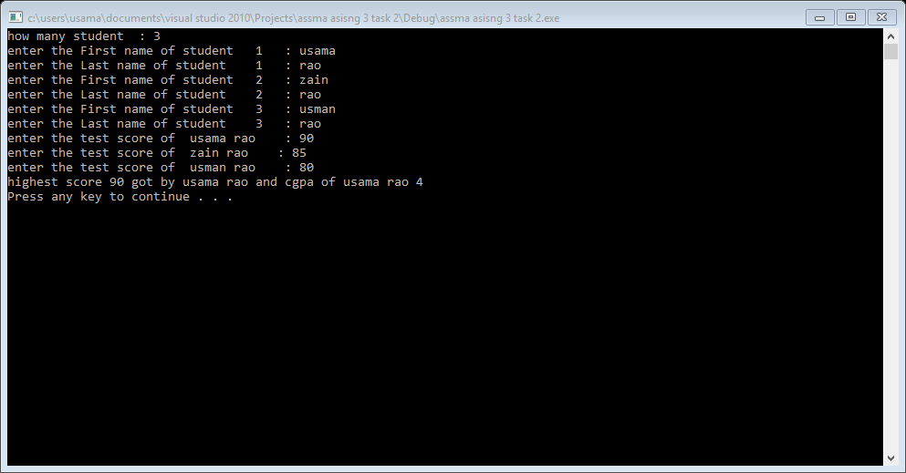

Task 3:

#include<iostream>

#include<string>

using namespace std;

struct uni

{

string name;

float quiz1;

float quiz2;

float quizt;

float mid;

float finall;

float score;

char grade;

};

int main()

{

int size=0;

cout<<"eneter the no of student for which you calculuate the marks : ";

cin>>size;

uni *arry;

arry=new uni[size];

for(int i=0; i<size; i++)

{

cout<<"enter the name of student : "<<i+1<<endl;

cin>>arry[i].name;

}

for(int i=0; i<size; i++)

{

cout<<"enter maks out of 10 in quiz1 of "<<arry[i].name<<" : ";

cin>>arry[i].quiz1;

cout<<"enter maks out of 10 in quiz2 of "<<arry[i].name<<" : ";

cin>>arry[i].quiz2;

cout<<"enter maks out of 100 in mid of "<<arry[i].name<<" : ";

cin>>arry[i].mid;

cout<<"enter maks out of 100 in finall of "<<arry[i].name<<": ";

cin>>arry[i].finall;

arry[i].quizt=(((arry[i].quiz1)/10)+((arry[i].quiz2)/10));

}

for(int i=0; i<size; i++)

{

arry[i].quizt=((arry[i].quizt/2))*25;

arry[i].mid=(arry[i].mid/100)*25;

arry[i].finall=(arry[i].finall/100)*50;

arry[i].score=(arry[i].quizt+arry[i].mid+arry[i].finall);

}

for(int i=0; i<size; i++)

{

cout<<"total score in 1st semester of "<<arry[i].name<<" : "<<arry[i].score<<endl;

}

for(int i=0; i<size; i++)

{

if(arry[i].score>=90)

{

arry[i].grade='A';

}

else if(arry[i].score>=80)

{

arry[i].grade='B';

}

else if(arry[i].score>=70)

{

arry[i].grade='C';

}

else if(arry[i].score>=60)

{

arry[i].grade='D';

}

else

{

arry[i].grade='F';

}

cout<<"GRADE OF "<<arry[i].name<<" : "<<arry[i].grade<<endl;

}

delete []arry;

arry=NULL;

system("pause");

return 0;

}

Result:

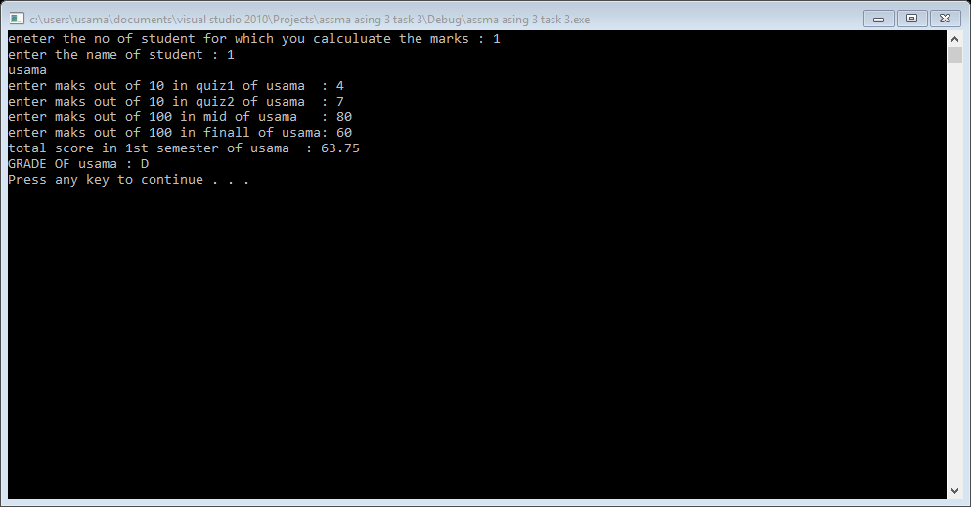

Task 4:

#include<iostream>

#include<string>

using namespace std;

struct employee

{

string number;

double compensation;

}arry[3];

int main()

{

cout<<"enter data for three employes "<<endl;

for(int i=0; i<3; i++)

{

cout<<"enter employ number : ";

cin>>arry[i].number;

cout<<"enter employ compensation : ";

cin>>arry[i].compensation;

}

for(int i=0; i<3; i++)

{

cout<<"employ number : "<<arry[i].number<<": and his compensation : "<<arry[i].compensation<<endl;

}

delete []arry;

arry=NULL;

system("pause");

return 0;

}

Result:

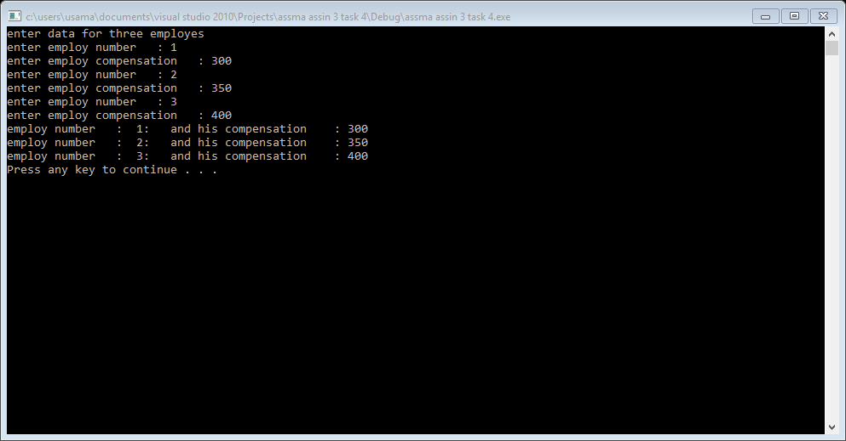

Task 5:

#include<iostream>

using namespace std;

struct parts

{

int model;

int part;

int cost;

};

int main()

{

int size=0;

cout<<"how many record you want to store : ";

cin>>size;

parts *arry;

arry=new parts[size];

for(int i=0; i<size; i++)

{

cout<<"enter model number : ";

cin>>arry[i].model;

cout<<"enter part number : ";

cin>>arry[i].part;

cout<<"enter cost : ";

cin>>arry[i].cost;

}

for(int i=0; i<size; i++)

{

cout<<"model : "<<arry[i].model<<" : ";

cout<<"part : "<<arry[i].part<<" : ";

cout<<"cost : "<<arry[i].cost<<" : "<<endl;

}

delete []arry;

arry=NULL;

system("pause");

return 0;

}

Result: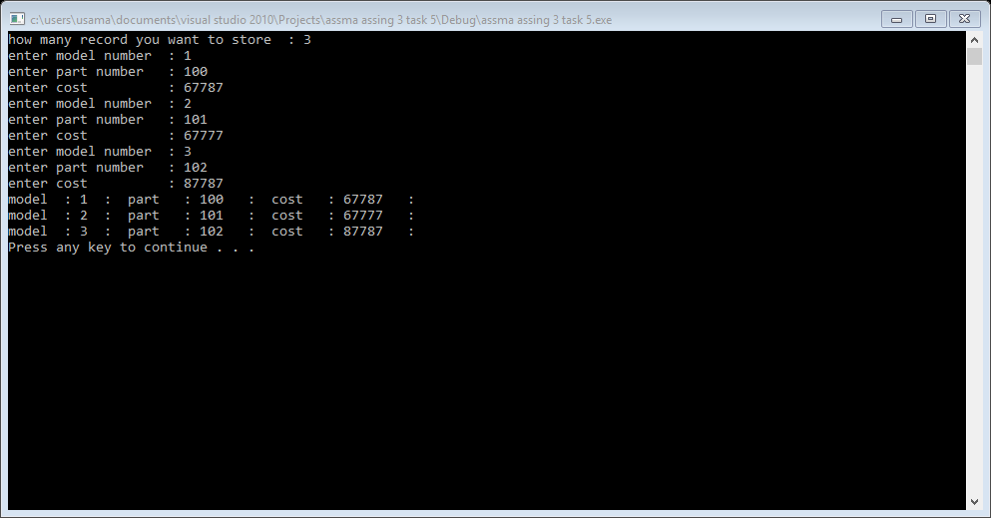

Task 6:

#include<iostream>

#include<string>

using namespace std;

struct uni

{

string name;

float quiz1;

float quiz2;

float quizt;

float mid;

float finall;

float score;

char grade;

};

int main()

{

int size=0;

cout<<"eneter the no of student for which you calculuate the marks : ";

cin>>size;

uni *arry;

arry=new uni[size];

for(int i=0; i<size; i++)

{

cout<<"enter the name of student : "<<i+1<<endl;

cin>>arry[i].name;

}

for(int i=0; i<size; i++)

{

cout<<"enter maks out of 10 in quiz1 of "<<arry[i].name<<" : ";

cin>>arry[i].quiz1;

cout<<"enter maks out of 10 in quiz2 of "<<arry[i].name<<" : ";

cin>>arry[i].quiz2;

cout<<"enter maks out of 100 in mid of "<<arry[i].name<<" : ";

cin>>arry[i].mid;

cout<<"enter maks out of 100 in finall of "<<arry[i].name<<": ";

cin>>arry[i].finall;

arry[i].quizt=(((arry[i].quiz1)/10)+((arry[i].quiz2)/10));

}

for(int i=0; i<size; i++)

{

arry[i].quizt=((arry[i].quizt/2))*25;

arry[i].mid=(arry[i].mid/100)*25;

arry[i].finall=(arry[i].finall/100)*50;

arry[i].score=(arry[i].quizt+arry[i].mid+arry[i].finall);

}

for(int i=0; i<size; i++)

{

cout<<"total score in 1st semester of "<<arry[i].name<<" : "<<arry[i].score<<endl;

}

for(int i=0; i<size; i++)

{

if(arry[i].score>=90)

{

arry[i].grade='A';

}

else if(arry[i].score>=80)

{

arry[i].grade='B';

}

else if(arry[i].score>=70)

{

arry[i].grade='C';

}

else if(arry[i].score>=60)

{

arry[i].grade='D';

}

else

{

arry[i].grade='F';

}

cout<<"GRADE OF "<<arry[i].name<<" : "<<arry[i].grade<<endl;

}

delete []arry;

arry=NULL;

system("pause");

return 0;

}

Result:

